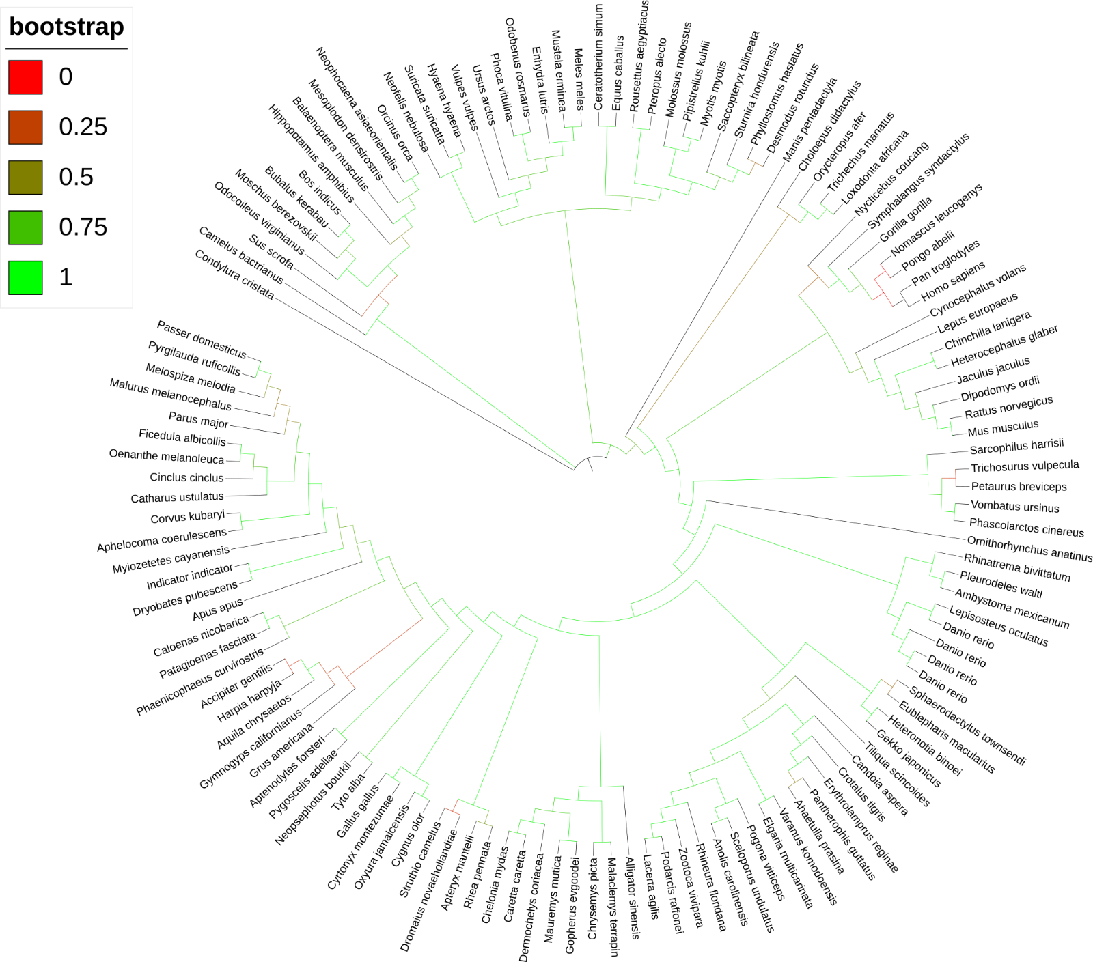

**Supplementary Figure 1: Bootstrap values of the initial DNMT3A tree.** Branches with lower (<0.5) had closely related species added to them to attempt to increase the associated bootstrap value. This was successful for some branches, but not all, as some branches had no more sequences to be added. Number of sequences increased from 151-221.

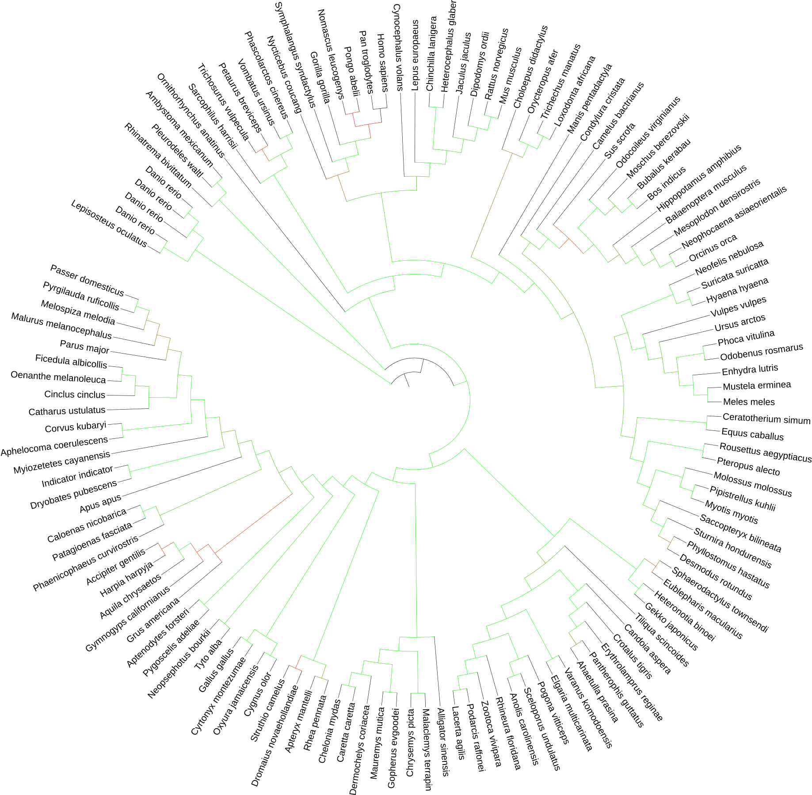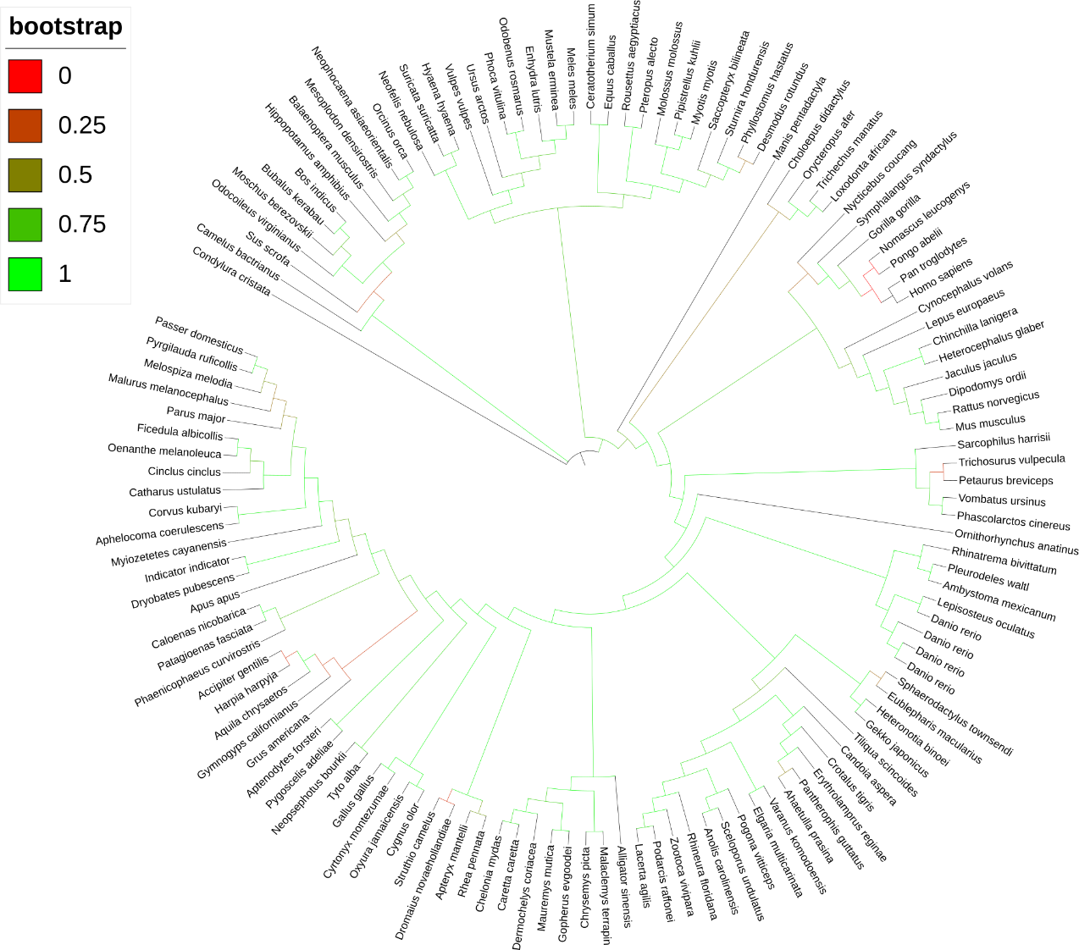

**Supplementary Figure 2: Bootstrap values of the initial DNMT3B tree.** Branches with lower (<0.5) had closely related species added to them to attempt to increase the associated bootstrap value. This was successful for some branches, but not all, as some branches had no more sequences to be added. Number of sequences increased from 126-129.

**Supplementary Figure 3:** AlphaFold 3 models of DNMT3A PWWP domains. **A:** Snake, total pTM: 0.44. **B:** Alligator, total pTM 0.46. **C:** Turtle, total pTM 0.44. **D:** Human. **E:** Frog, total pTM 0.45. **F:** Fish, total pTM: 0.46. **G:** Shark, total pTM: 0.42**. H:** Lamprey, total pTM: 0.42**.**

**Supplementary Figure 4:** AlphaFold3 models of DNMT3B PWWP domain. **A:** Snake, total pTM: 0.51**. B:** Alligator, total pTM: 0.52**. C:** Turtle, total pTM: 0.53. **D:** Human. **E:** Axolotl, total pTM: 0.45 **F:** Fish, total pTM: 0.5.

**Supplementary Figure 5:** AlphaBridge binding models of jawless fish sequences with low cut-offs (left) and default cut-offs (right). **A:** *Lampetra planeri*; accession: CAL5920502.1.**B:** *Petromyzon marinus*; accession: XP_032810496.1. **C:** *Myxine glutinosa*; accession: XP_067964224.1. **D:** *Lethenteron reissneri*; accession: XP_061416605.1. **E:** *Lampetra fluviatilis*: accession: CAL5909409.1. Sections are as follows (clockwise): H2A x2, H2B x2, H3, H4, UDR motif + PWWP domain, dsDNA.

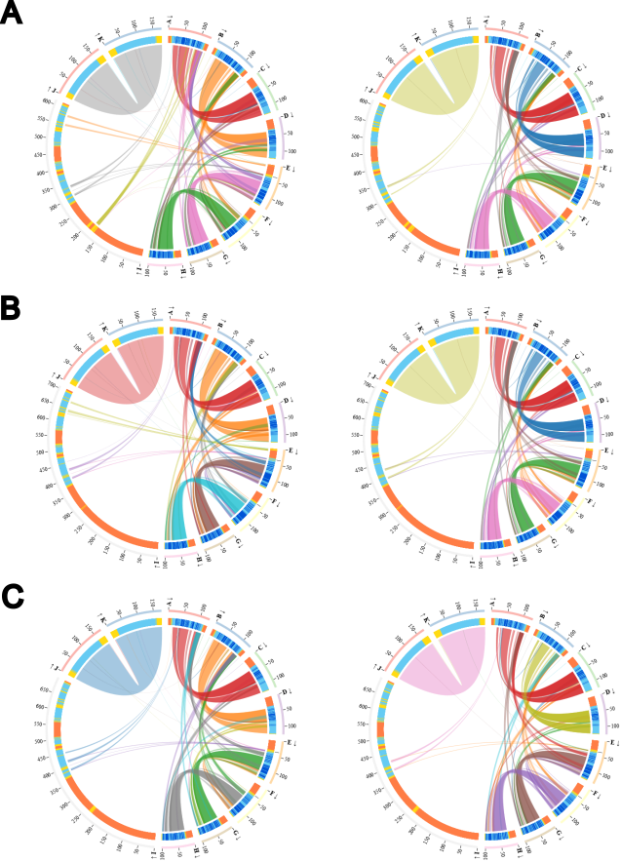

**Supplementary Figure 6: DNMT3-nucleosome AlphaBridge Predictions**. **A:** *Alligator sinensis*; accession: XP_006032431.2. **B:** *Crotalus adamanteus*; accession: KAK9412286.1. **C:** *Dermochelys coriacea*; accession: XP_043365894.1. Sections are as follows (clockwise): H2A x2, H2B x2, H3, H4, UDR motif + PWWP domain, dsDNA.

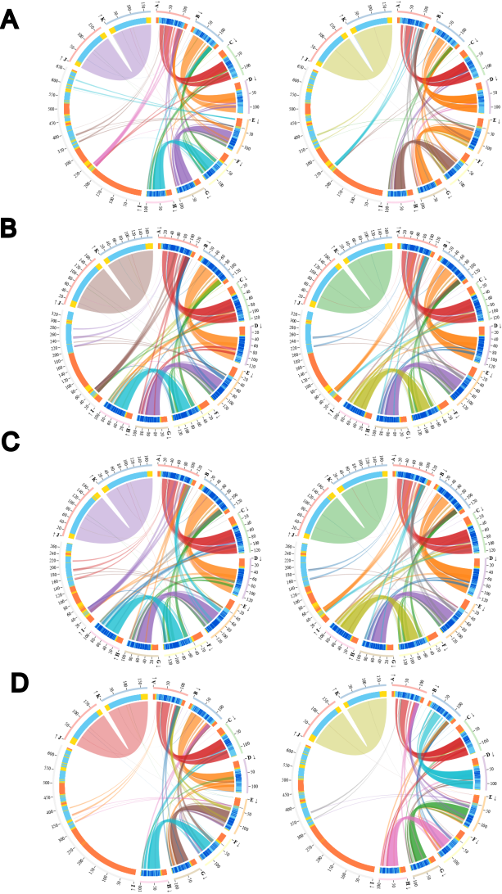

**Supplementary Figure 7: DNMT3-nucleosome AlphaBridge Predictions**. **A**: *Erpetiochthys calabaricus*; accession: XP_051780532.1. **B:** *Heterodontus francisci*; accession: XP_067879915.1. **C:** *Homo sapiens*; accession: Q9Y6K1. **D:** *Xenopus laevis*: accession: XP_041419590.1. Sections are as follows (clockwise): H2A x2, H2B x2, H3, H4, UDR motif + PWWP domain, dsDNA.

|  |  |  |  |  |
| --- | --- | --- | --- | --- |
| Species | Name of Gene | Description | GLAM2Scan Accession | Associated Accession |
| *P. marinus_7.0* | Novel Gene | | ENSPMAP00000007623.1 | ENSPMAG00000006920 |
| ENSPMAP00000001352.1 | ENSPMAG00000001228 |
| ENSPMAP00000004919.1 | ENSPMAG00000004478 |
| CCD186 | Coiled-coil domain containing 186 | ENSPMAP00000004944.1 | ENSPMAG00000004488 |
| Novel Gene | | ENSPMAP00000000332.1 | ENSPMAG00000000298 |
| eea1 | Early endosome antigen 1 | ENSPMAP00000003327.1 | ENSPMAG00000003037 |
| Novel Gene | CWF19 like cell cycle control factor 2 | ENSPMAP00000007910.1 | ENSPMAG00000007158 |
| Novel Gene | | ENSPMAP00000002618.1 | ENSPMAG00000002392 |
| ENSPMAP00000002950.1 | ENSPMAG00000002707 |
| Tcerg1a | Transcription elongation regulator 1a | ENSPMAP00000001070.1 | ENSPMAG00000000963 |
| ENSPMAP00000001075.1 | ENSPMAG00000000963 |
| Novel Gene | | ENSPMAP00000010251.1 | ENSPMAG00000009324 |
| ENSPMAP00000001313.1 | ENSPMAG00000001168 |
| ENSPMAP00000007623.1 | ENSPMAG00000006920 |
| Novel Gene | Progesterone immunomodulatory binding factor 1 | ENSPMAP00000003689.1 | ENSPMAG00000003378 |
| Novel Gene | | ENSPMAP00000003178.1 | ENSPMAG00000002914 |
| ENSPMAP00000009620.1 | ENSPMAG00000008727 |
| ENSPMAP00000009925.1 | ENSPMAG00000009022 |
| ENSPMAP00000009926.1 | ENSPMAG00000009022 |
| ENSPMAP00000005667.1 | ENSPMAG00000005147 |
| Novel Gene | CWF19 like cell cycle control factor 2 | ENSPMAP00000007910.1 | ENSPMAG00000007158 |
| Novel Gene | V-myb avian myeloblastosis viral oncogene homolog-like 1 | ENSPMAP00000001822.1 | ENSPMAG00000001639 |
| kif17 | Kinesin family member 17 | ENSPMAP00000010571.1 | ENSPMAG00000009612 |
| Novel Gene | | ENSPMAP00000002973.1 | ENSPMAG00000002725 |
| ENSPMAP00000010038.1 | ENSPMAG00000009122 |

**Supplementary Table 1:** **Table of GLAM2Scan results.**